**DAILY ONLINE ACTIVITIES SUMMARY**

|  |  |  |  |  |  |  |  |  |
| --- | --- | --- | --- | --- | --- | --- | --- | --- |
| **Date:** | **16-7-2020** | | | | | **Name:** | **Prajna** | |
| **Sem & Sec** | **8th sem ‘B’** | | | | | **USN:** | **4AL16CS067** | |
| **Online Test Summary** | | | | | | | | |
| **Subject** | | **-** | | | | | | |
| **Max. Marks** | | **-** | | **Score** | | | **-** | |
| **Certification Course Summary** | | | | | | | | |
| **Course** | **Introduction to CSS** | | | | | | | |
| **Certificate Provider** | | | **Great learning** | | **Duration** | | | **5hrs** |
| **Coding Challenges** | | | | | | | | |
| **Problem Statement:**1**.** Write a c program to find the sums of rows and columns. | | | | | | | | |
| **Status: Completed** | | | | | | | | |
| **Uploaded the report in GitHub**  **GitHub link:** | | | | | **Yes**  **https://github.com/alvas-education-foundation/prajna_k** | | | |
| **If yes Repository name** | | | | | **prajna_k** | | | |
| **Uploaded the report in slack** | | | | | **yes** | | | |

Online Test Details: (Attach the snapshot and briefly write the report for the same)

Certification Course Details: (Attach the snapshot and briefly write the report for the same)

Coding Challenges Details: (Attach the snapshot and briefly write the report for the same)

2) certification course

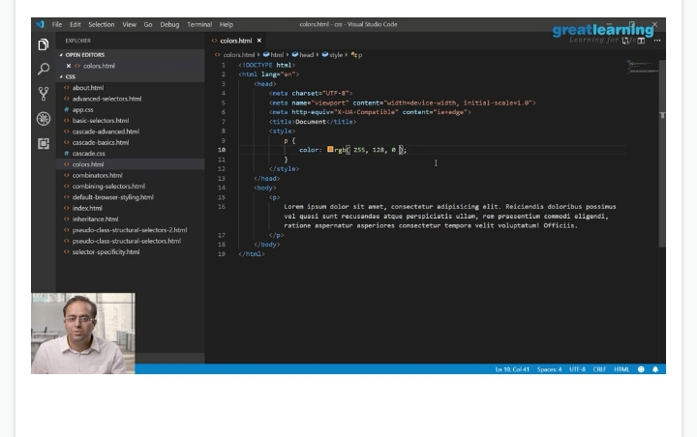

3) coding challenges

#include <stdio.h>

void main()

{

int i,j,k,arr1[10][10],rsum[10],csum[10],n;

printf("\n\nFind the sum of rows an columns of a Matrix:\n");

printf("-------------------------------------------\n");

printf("Input the size of the square matrix : ");

scanf("%d", &n);

printf("Input elements in the first matrix :\n");

for(i=0;i<n;i++)

{

for(j=0;j<n;j++)

{

printf("element - [%d],[%d] : ",i,j);

scanf("%d",&arr1[i][j]);

}

}

printf("The matrix is :\n");

for(i=0;i<n;i++)

{

for(j=0;j<n ;j++)

printf("% 4d",arr1[i][j]);

printf("\n");

}

/* Sum of rows */

for(i=0;i<n;i++)

{

rsum[i]=0;

for(j=0;j<n;j++)

rsum[i]=rsum[i]+arr1[i][j];

}

/* Sum of Column */

for(i=0;i<n;i++)

{

csum[i]=0;

for(j=0;j<n;j++)

csum[i]=csum[i]+arr1[j][i];

}

printf("The sum or rows and columns of the matrix is :\n");

for(i=0;i<n;i++)

{

for(j=0;j<n;j++)

printf("% 4d",arr1[i][j]);

printf("% 8d",rsum[i]);

printf("\n");

}

printf("\n");

for(j=0;j<n;j++)

{

printf("% 4d",csum[j]);

}

printf("\n\n");

}

|  |
| --- |
|  |
|  |  |
|  |  |
|  |  |
|  |  |
|  |  |